# Solitaire

## Definition

**# Source**: **Chatgpt (GPT-5-Standard) at [8/27/2025]**

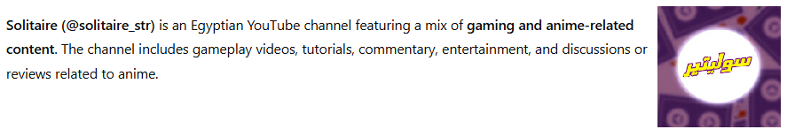

**Solitaire (@solitaire_str)** is an Egyptian YouTube channel featuring a mix of **gaming and anime-related content**. The channel includes gameplay videos, tutorials, commentary, entertainment, and discussions or reviews related to anime.

## Key Highlights

**# Source**: **Chatgpt (GPT-5-Standard) at [8/27/2025]**

* Approximately **2.9K subscribers**
* Around **60 videos** uploaded
* Focus on **gaming and anime** content: gameplay, tutorials, tips, entertainment, and anime discussions
* Active on **TikTok, Instagram, and Facebook** for additional content
* Engages viewers through live streams and interactive gameplay

## Summary Table

**# Source**: **Chatgpt (GPT-5-Standard) at [8/27/2025]**

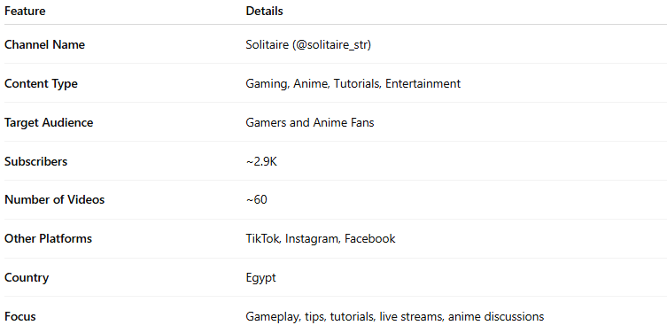

| **Feature** | **Details** |
| --- | --- |
| **Channel Name** | Solitaire (@solitaire_str) |
| **Content Type** | Gaming, Anime, Tutorials, Entertainment |
| **Target Audience** | Gamers and Anime Fans |
| **Subscribers** | ~2.9K |
| **Number of Videos** | ~60 |
| **Other Platforms** | TikTok, Instagram, Facebook |
| **Country** | Egypt |
| **Focus** | Gameplay, tips, tutorials, live streams, anime discussions |